**Bluetooth controlled car using mobile application**

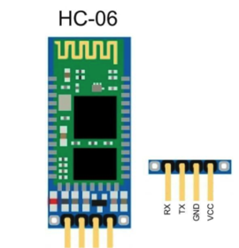**Introduction**

In this project,The android app sends data packets to the Bluetooth module. The Bluetooth modules sends this data packet to Arduino Uno through Serial Communication. A Bluetooth-controlled car is a simple car that runs on a wireless Bluetooth signal. In Arduino, we have mainly  **Bluetooth Options HC-06 module**

**Components**

* 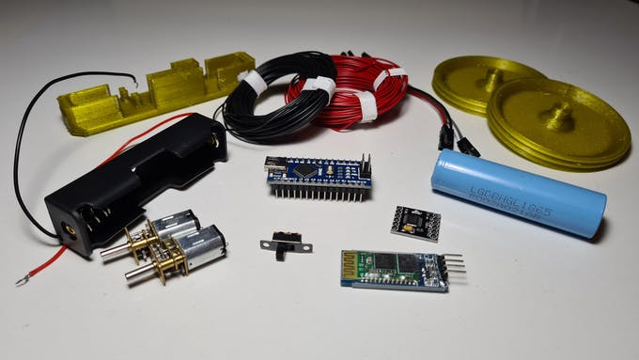Arduino nano
* Micrometal gear motor-600RPM 12v
* DRV8833 motor driver
* HC-06 bluetooth module
* Battery and battery holder
* Switch
* Connecting wires
* breadboard

**Application**

* The [Bluetooth](http://www.polytechnichub.com/advantages-disadvantages-bluetooth/) is used in wireless head sets.
* Bluetooth is used to transfer files, images and MP3 or MP4 between cell phones.
* It is used in laptops and notebooks.
* It is used in PDAs (personal digital assistant).
* It is also used in printers.
* It is almost used in wireless communication (WAN).
* It is used in wireless mouse and keyboards.
* It is used in data logging equipment data logging equipment that transmit data to a computer via Bluetooth technology.
* It is used for sending small advertisements from Bluetooth enabled advertising hoardings to other, discoverable, Bluetooth devices.
* It is used in short range transmission of health sensor data from medical devices to mobile phone,set top box or dedicated tele health

**Objective**

**flowchart**

**Program**

#include <SoftwareSerial.h>

SoftwareSerial BT(10, 11);

// creates a "virtual" serial port/UART

// connect BT module TX to D10

// connect BT module RX to D11

// connect BT Vcc to 5V, GND to GND

//we define the pins that set the motors' direction

int motor1a = 2;

int motor1b = 3;

int motor2a = 4;

int motor2b = 5;

void setup()

{

// we define the motor pins as outputs

pinMode(motor1a, OUTPUT);

pinMode(motor1b, OUTPUT);

pinMode(motor2a, OUTPUT);

pinMode(motor2b, OUTPUT);

BT.begin(9600);// set the data rate for the SoftwareSerial port

}

char a; // stores incoming character from other device

void loop()

{

if (BT.available())

// if text arrived in from BT serial

{

a=(BT.read());//it will be read and

if (a=='1')//if a=1 (the signal from the 'up' button from the bluetooth app) it will move forward

{

digitalWrite(motor1a, LOW);

digitalWrite(motor1b, HIGH);

digitalWrite(motor2a, LOW);

digitalWrite(motor2b, HIGH);

}

if (a=='2')//it will move backwards

{

digitalWrite(motor1a, HIGH);

digitalWrite(motor1b, LOW);

digitalWrite(motor2a, HIGH);

digitalWrite(motor2b, LOW);

}

if (a=='3')// it will move left

{

digitalWrite(motor1a, HIGH);

digitalWrite(motor1b, LOW);

digitalWrite(motor2a, LOW);

digitalWrite(motor2b, HIGH);

}

if (a=='4')//it will move right

{

digitalWrite(motor1a, LOW);

digitalWrite(motor1b, HIGH);

digitalWrite(motor2a, HIGH);

digitalWrite(motor2b, LOW);

}

if (a=='0')//it will not move

{

digitalWrite(motor1a, LOW);

digitalWrite(motor1b, LOW);

digitalWrite(motor2a, LOW);

digitalWrite(motor2b, LOW);

}

}

}

**Hardware**

* Connect the VCC of the HC-06 and DRV8833 to 5V
* Connect the GND of the HC-06 and DRV8833 to GND
* Connect the TXD to D10
* Connect the RXD to D11
* Connect INT1, INT2, INT3, INT4 to D2, D3, D4, D5 accordingly
* Connect the first motor's cables to OUT1 and OUT2
* Connect the second motor's cables to OUT3 and OUT4
* Connect the battery's "" to 5V and the "-" to GND

